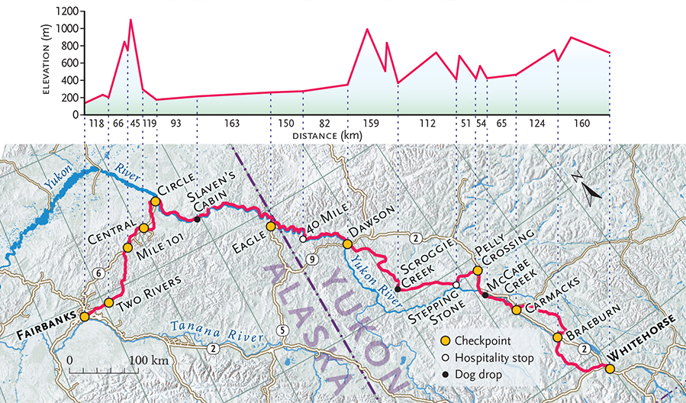

Date | Name | Minutes Read
Feb.
1
Total Minutes Read:

Date | Name | Minutes Read
Feb.
2
Total Minutes Read:

Date | Name | Minutes Read
Feb.
5
Total Minutes Read:

Date | Name | Minutes Read
Feb.
6
Total Minutes Read:

Date | Name | Minutes Read
Feb.
7
Total Minutes Read:

Date | Name | Minutes Read
Feb.
8
Total Minutes Read:

Date | Name | Minutes Read
Feb.
9
Total Minutes Read:

Date | Name | Minutes Read
Feb.
12
Total Minutes Read:

Date | Name | Minutes Read
Feb.
13
Total Minutes Read:

Date | Name | Minutes Read
Feb.
14
Total Minutes Read:

Date | Name | Minutes Read
Feb.
15
Total Minutes Read:

Date | Name | Minutes Read
Feb.
20
Total Minutes Read:

Date | Name | Minutes Read
Feb.
21
Total Minutes Read:

Date | Name | Minutes Read
Feb.
22
Total Minutes Read:

Date | Name | Minutes Read
Feb.
23
Total Minutes Read:

Date | Name | Minutes Read
Feb.
26
Total Minutes Read:

Date | Name | Minutes Read
Feb.
27
Total Minutes Read:

Date | Name | Minutes Read
Feb.
28
Total Minutes Read:

Date | Name | Minutes Read
Feb.
27
Total Minutes Read:

Date | Name | Minutes Read
Feb.
28
Total Minutes Read:

